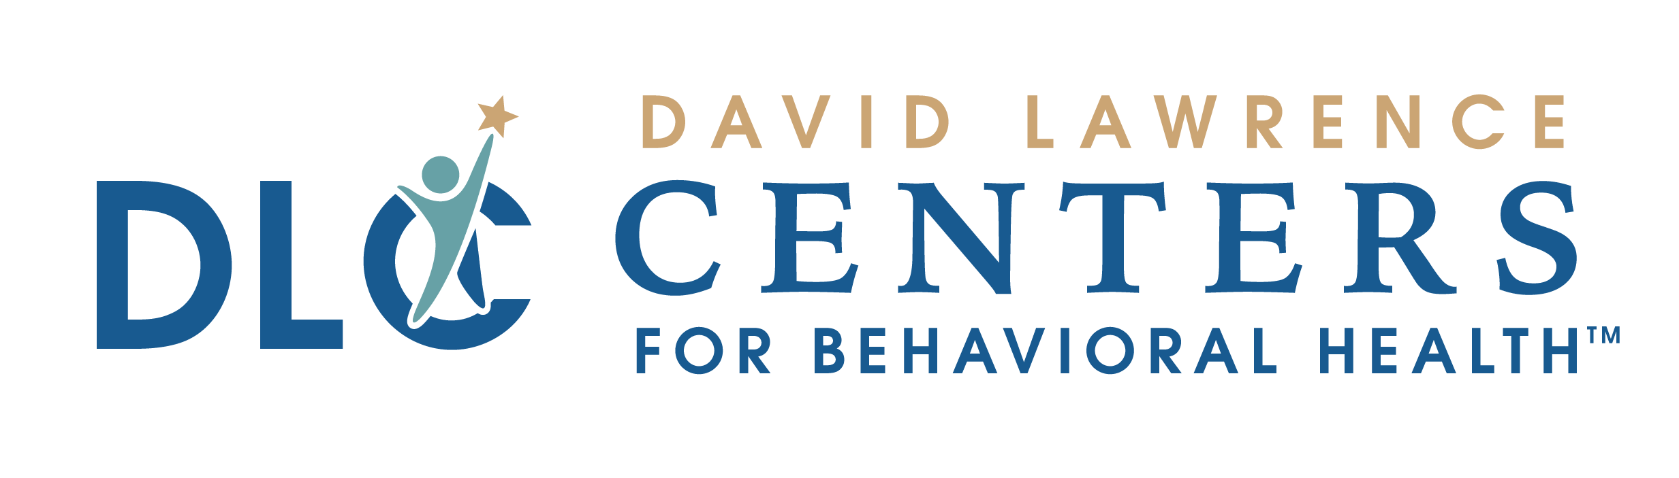
PATIENT
INFORMATION
David Lawrence Centers
For Behavioral Health
6075 Bathey Lane
Naples, FL 34116
To make an appointment please call:
239-455-8500

What you need to know about
Advance Directives

At David Lawrence Centers for Behavioral Health (DLC), clients are encouraged to make decisions concerning their health care before they become incapacitated. We believe that understanding the client’s personal views and values are vital in order to best determine the care provided.

Under Florida law, patients have the right to accept or refuse medical or surgical treatment and to prepare a living will or similar document. Although the Center is not a hospital facility, we ask that you inform the admission/intake staff if you have completed any of the following documents and that you present the Center with a copy for filing in your clinical record:

Health Care Surrogate
Florida statutes provide that any competent adult patient may designate a person to serve as a health care surrogate to make health care decisions for him/her and to provide informed consent for treatment. A health care surrogate may be asked to make treatment decisions for clients in our crisis unit. A Health Care Surrogate cannot voluntarily admit a person to the Center’s Residential Programs, to include the CSU. Please let us know if you have already appointed a Health Care Surrogate.

Durable Power of Attorney
Patients who have executed a durable power of attorney document have legally named an adult individual as their agent for the purpose of making treatment or refusal of treatment decisions. Such agents have the legal authority to refuse that resuscitation measures be employed in a hospital setting.

Advance Directive (Living Will)
Any competent adult has the legal right to refuse medical intervention, including life-saving procedures. This document is a written-signed declaration instructing the responsible physician to withhold or withdraw resuscitation measures when the patient is in a terminal condition and unable to communicate his/her wishes. Local hospital facilities will ask if you have completed a Living Will.

Should you have interest in obtaining any of these documents, contact your attorney or call the Center for Aging Resources Elder Help Line at 1-800-262-2243 for a complimentary Living Will packet.
This information is for educational purposes only and should not be relied upon as medical advice. It has not been designated to replace a physician’s independent judgment about the appropriateness or risks of a procedure, treatment, and/or services for a given patient.

MED-104 Advance Directives Education Handout Rev. 1/04, 3/08, 10/10

