How to complete the Release of Information online Adult:
- Go to https://davidlawrencecenter.org/
- Click the Get Help Now bottom at the top in Blue:

- You will then scroll down to bottom to Client Form:
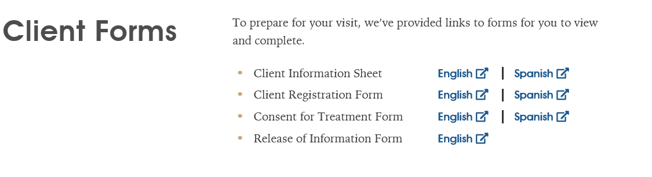
- Click on Release of Information form:
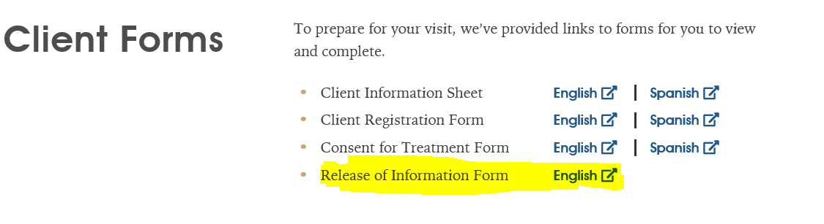
- When you click Release of Information, it will take you to the following:
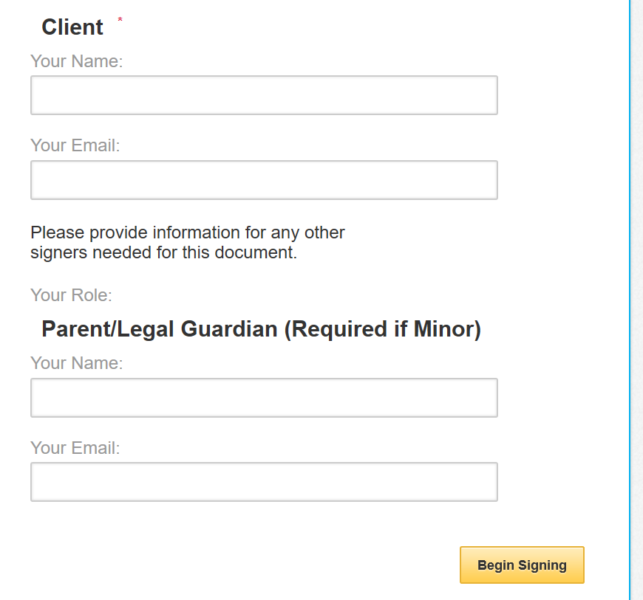

- You will fill out the client section and enter your email address. It should look like the following:
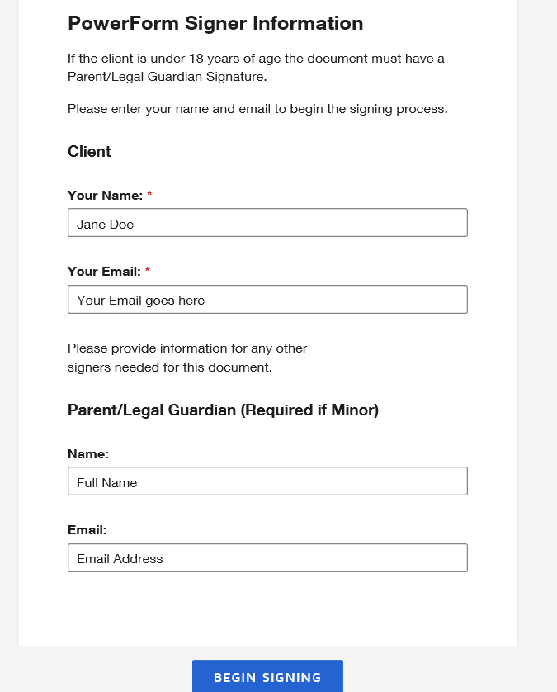

- When you click begin signing it will take you to the Release of information:

- You will click the following to start:

- You will see your client name at the top. You will need to enter your DOB. You will also need to click the Release and Obtain boxes: 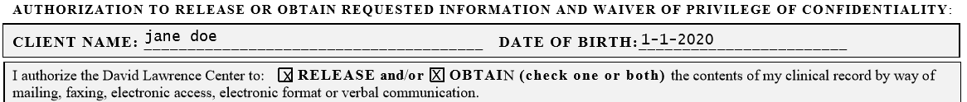

- For the Name of Individual, Hospital or Agency, you will enter name to release. For example, if filling out for yourself then it would be the following below. Your name, Relationship is self. Then enter Phone number. If the release is for a Doctor, Attorney, etc. then a fax and address must be included also. If you are having records mailed to yourself an address must also be entered.
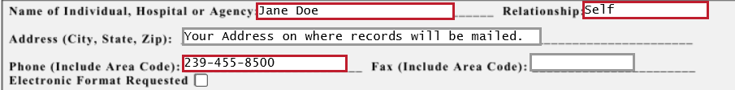

- You will move on to the Initial part. You will need to be sure to initial for Mental Health records. If you have a Substance Use Diagnosis or Diagnosis of HIV/AIDS initials are needed for the release to be valid.

- The next section will have you Initialing for the services to be released. Please initial for what service you want release or to obtain for request. After Initialing the services, you will then click what you are authorizing the purpose of disclosure is. For example, continuity of care would be initialed if the Release is for Parents or Doctor office. Legal if for DJJ, Probation and Lawyer. The below is what the initials section should look like:
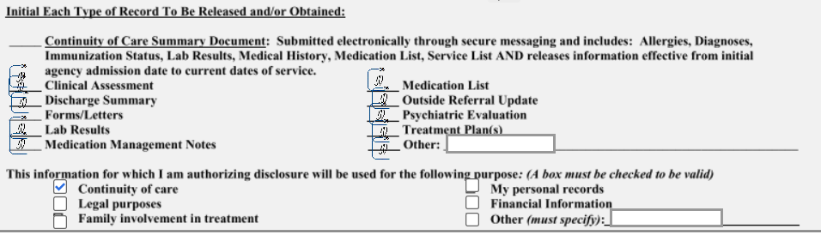

- The final Initial at the bottom is needed agreeing that you have read and fully understand the terms of this release and waiver. Next, you will click sign as the client.
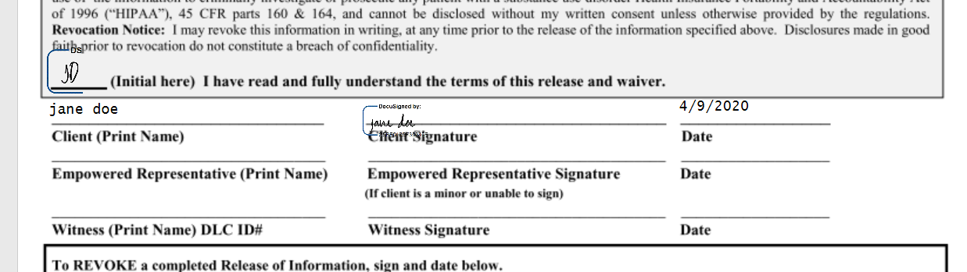

- When you are done with signing, you will then click finish and it will email our medical records department. The release should look like the below. If you need any help or have any questions, please contact the medical records dept at 239-345-1403. When Medical records approves the release, you will get confirmation email. If the release is not completed correctly, you will receive an email denying the release and why then a new release will need to be completed.
