How to complete the Release of Information online for Minors:
- Go to https://davidlawrencecenter.org/
- Click the Get Help Now bottom at the top in Blue:
- You will then scroll down to see Client form:
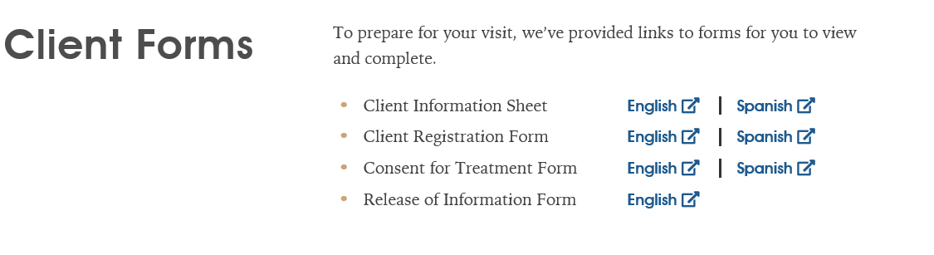
- Click on Release of Information form:
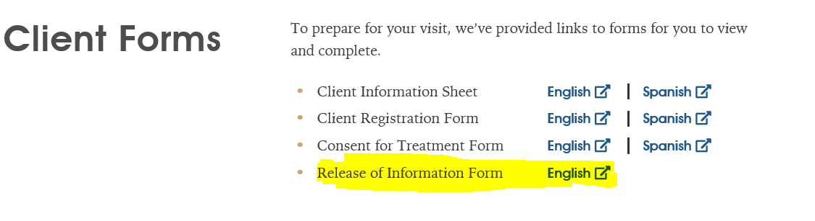
- When you click Release of Information, it will take you to the following: 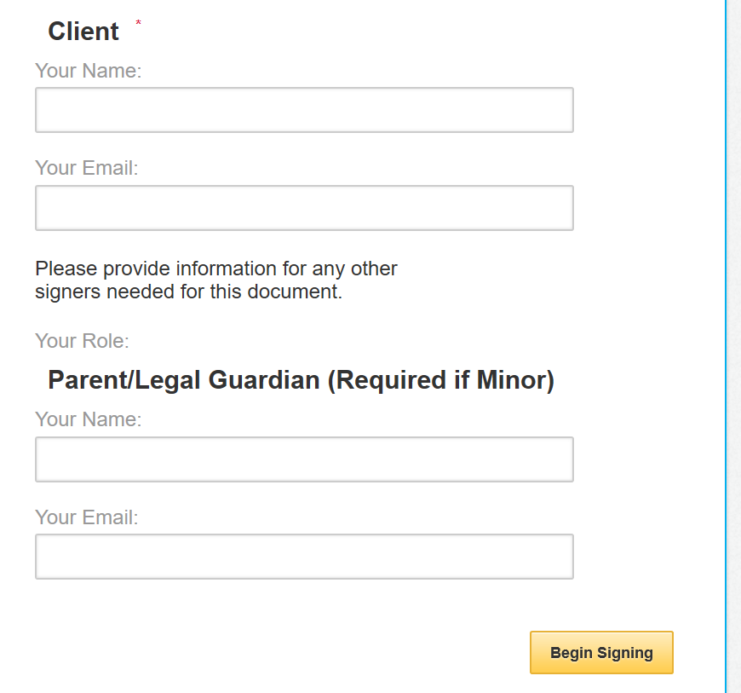

- You will fill in child name in the client section and enter your email address. Then, you will enter your name for the parent and your email address again. It should look like the following:
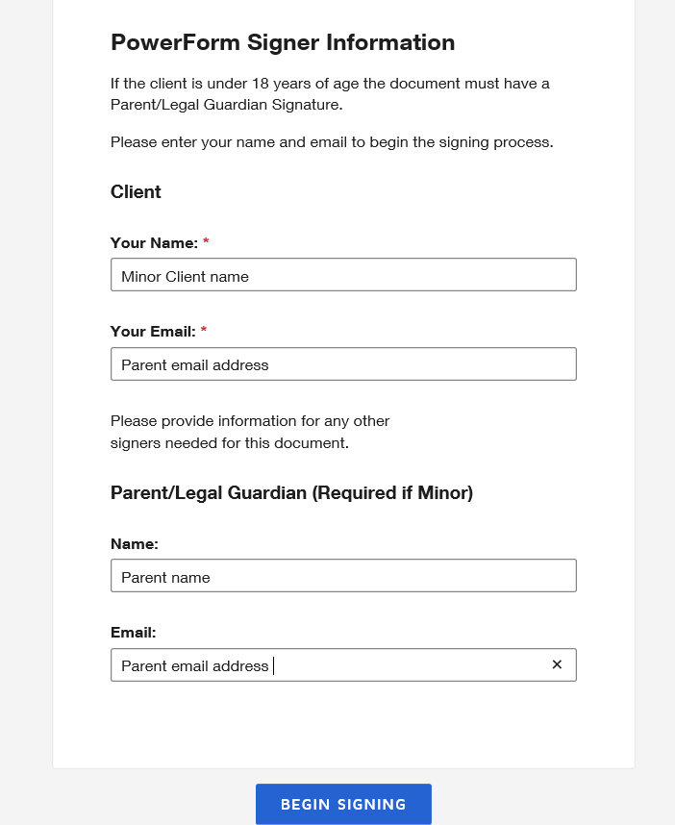

- When you click begin signing it will take you to the Release of Information:

- You will click the following to start:

- You will see your child’s name at the top. You will need to enter the Child DOB. You will also need to click the Release and Obtain boxes:

- For the Name of Individual, Hospital or Agency, you will enter name to release. For example, if filling out for yourself (parent) then it would be Parent name, relationship is Mother or Father. Then enter phone number and address. If the release is for a doctor’s office, Probation, DJJ, BAYS FL, etc., then a fax must be included also. 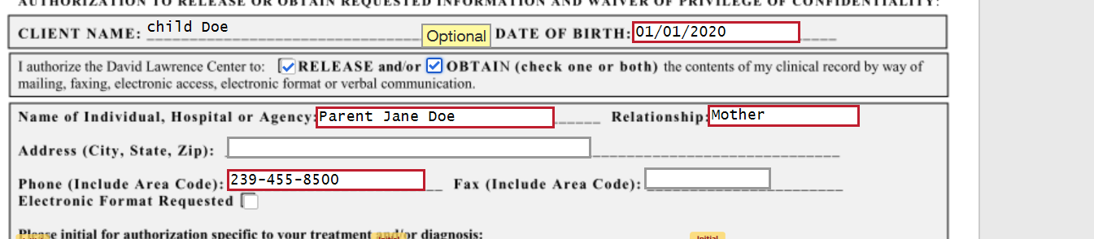

- You will move on to the Initials part. As you are filling out for a minor, the minor’s initials will be the initials that are entered. This how the website works. You will need to be sure to initial for Mental Health records. If the child has a Substance Use Diagnosis, then Substance Use also needs to be initialed for the release to be valid.

- The next section will have you Initialing for the services to be released or records your wanting to obtain. After Initialing the services, you will then click what you are authorizing the purpose of disclosure is. For example, continuity of care would be initialed if the Release is for Parents or a Doctor office. Legal for DJJ, Probation and Lawyer. The below is what the initials section should look like: 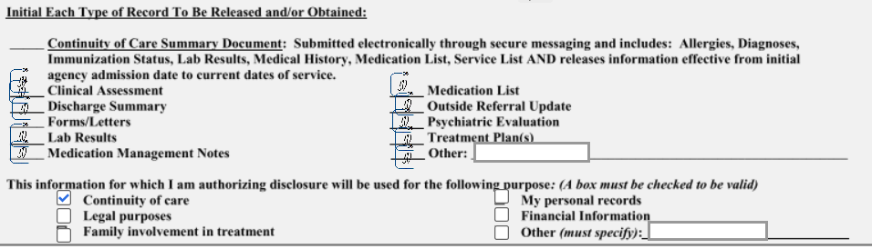

- The final Initial at the bottom is needed agreeing that you have read and fully Understand the terms of this release and waiver. Next, you will click sign as the client (Minor). 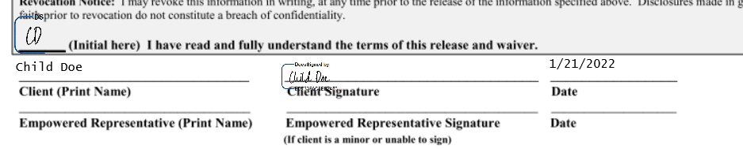
- After you click finish, an email with be sent to the email address you entered at the beginning. You will open the link to review this is when you as the parent will sign your name on the empowered representative line.
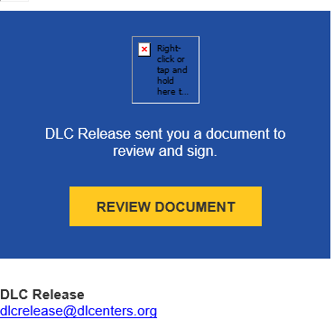
- When you are done with signing, you will then click finish and it will auto email over to our medical records department. The release should look like the below. If you need any help or have any questions, please contact the medical records dept at 239-345-1403. When Medical records approves the release, you will get confirmation email. If the release is not completed correctly, you will receive an email denying the release and why then a new release will need to be completed.
